

CSE 3023: PEMBANGUNAN APLIKASI BERASASKAN WEB

Lab Report 7
Name: CHONG YU
Matric No.: S76136
Group: K1
Program:
Computer Science (Software Engineering)

Activity 7.7
Output when changing “root” to others value
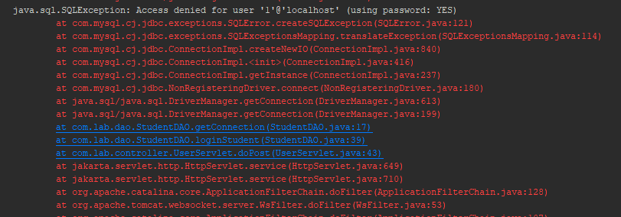

Output for activity 7.7


Lab Exercise
Login.html
<html>
<head>
<title>TODO supply a title</title>
<meta charset="UTF-8">
<meta name="viewport" content="width=device-width, initial-scale=1.0">
</head>
<body>
<h1>Login page</h1>
<form method="POST" action="dashboard.jsp">
<label>Matric No: </label>
<input type="text" name="matricNo" maxlength=7 required><br /><br />
<label>Password; </label>
<input type="text" name="password" maxlength=12 required><br /><br />
<input type="submit" value="Log In">
</form>
</body>
</html>

Dashboard.jsp

<%--
Document : dashboard
Created on : May 19, 2026, 3:15:58 PM
Author : Simon
--%>
<%@page contentType="text/html" pageEncoding="UTF-8"%>
<!DOCTYPE html>
<html>
<head>
<meta http-equiv="Content-Type" content="text/html; charset=UTF-8">
<title>Student Dashboard</title>
</head>
<body>
<%
HttpSession ses = request.getSession(true);
ses.setAttribute("matricNo", request.getParameter("matricNo"));
%>
<h1>Welcome ! Please choose action below..</h1>
<a href="${pageContext.request.contextPath}/subject/registerSubject.jsp">Register new subject..</a><br/>
<a href="${pageContext.request.contextPath}/subject/viewSubject.jsp">View subject..</a><br/>
</body>
</html>

ViewSubject.jsp

<%--
Document : viewSubject
Created on : May 19, 2026, 3:16:46 PM
Author : user
--%>
<%@page import="java.util.ArrayList"%>
<%@page import="com.lab.bean.subjectBean"%>
<%@page import="com.lab.dao.subjectDAO"%>
<%@page contentType="text/html" pageEncoding="UTF-8"%>
<!DOCTYPE html>
<html>
<head>
<meta http-equiv="Content-Type" content="text/html; charset=UTF-8">
<title>JSP Page</title>
</head>
<body>
<h1>Subject List</h1>
<%
subjectDAO subDAO = new subjectDAO();
ArrayList<subjectBean> subjectList = subDAO.viewSubject();
// Get matricNo
String matricNo = (String) session.getAttribute("matricNo");
%>
<p>Matric No: <%= matricNo %></p>
<%
for (int i = 0; i < subjectList.size(); i++) {
%>
<p>Subject Name: <%= subjectList.get(i).getSubjectName() %></p>
<p>Subject Code: <%= subjectList.get(i).getSubjectCode() %></p>
<a href="updateSubject.jsp?subjectCode=<%= subjectList.get(i).getSubjectCode() %>">Update subject</a>
<%
}
%>
<br/>
<a href="../dashboard.jsp">Back to Dahsboard</a>
</body>
</html>

UpdateSubject.jsp

<%--
Document : updateSubject
Created on : May 19, 2026, 3:16:40 PM
Author : user
--%>
<%@page import="com.lab.bean.subjectBean"%>
<%@page import="com.lab.dao.subjectDAO"%>
<%@page contentType="text/html" pageEncoding="UTF-8"%>
<!DOCTYPE html>
<html>
<head>
<meta http-equiv="Content-Type" content="text/html; charset=UTF-8">
<title>JSP Page</title>
</head>
<body>
<h1>Hello World!</h1>
<%
String subjectCode = request.getParameter("subjectCode");
subjectDAO subDAO = new subjectDAO();
subjectBean subject = subDAO.viewSubjectBySubjectCode(subjectCode);
%>
<form method="POST" action="${pageContext.request.contextPath}/subjectServlet?action=updateSubject">
<label>New Subject Name: </label>
<input type="text" name="subjectName" maxlength=30 value="<%= subject.getSubjectName() %>" required><br /><br />
<label>New Subject Code: </label>
<input type="text" name="subjectCode" maxlength=7 value="<%= subject.getSubjectCode() %>" required><br /><br />
<input type="submit" value="update">
</form>
</body>
</html>

registerSubject.jsp

<%--
Document : registerSubject
Created on : May 19, 2026, 3:16:32 PM
Author : user
--%>
<%@page contentType="text/html" pageEncoding="UTF-8"%>
<!DOCTYPE html>
<html>
<head>
<meta http-equiv="Content-Type" content="text/html; charset=UTF-8">
<title>Register new subject</title>
</head>
<body>
<h1>Please fill in form below..</h1>
<form method="POST" action="${pageContext.request.contextPath}/subjectServlet?action=registerSubject">
<label>Subject Name: </label>
<input type="text" name="subjectName" maxlength=30 required><br /><br />
<label>Subject Code: </label>
<input type="text" name="subjectCode" maxlength=7 required><br /><br />
<input type="submit" value="submit">
</form>
</body>
</html>

Output:

